1. Create a web page as follows: having 3 frames. KIIT University will move in marquee in the top frame. In the left frame 3 hyperlinks will be there and clicking on that the desired result will be displayed in the main frame.

|  |  |
| --- | --- |
| KIIT UNIVERSITY | |
| Login  About KIIT  Feedback |  |

1. 2. Create a webpage to display the student details in a table at least with 5 subject records. Use all the attributes like caption etc.

|  |  |  |  |  |  |  |
| --- | --- | --- | --- | --- | --- | --- |
| Roll No | Name | Subjects | Marks | Average | SGPA | Semester |
|  |  | Sub - 1 |  | rowspan |  | colspan |
| Sub - 2 |  |
| Sub - 3 |  |
| Sub - 4 |  |

1. 3Design a webpage with a table as follows using colspan and rowspan

|  |  |  |
| --- | --- | --- |
| A | | |
| B | C | |
| D | E |

1. Design a web page using all three kinds OF STYLE SHEET
2. Framing -

|  |  |  |
| --- | --- | --- |
| First Frame | Second Frame | |
| Third | Fourth Frame | |
| 5th | 6th |

1. Design a web page which will display the following form

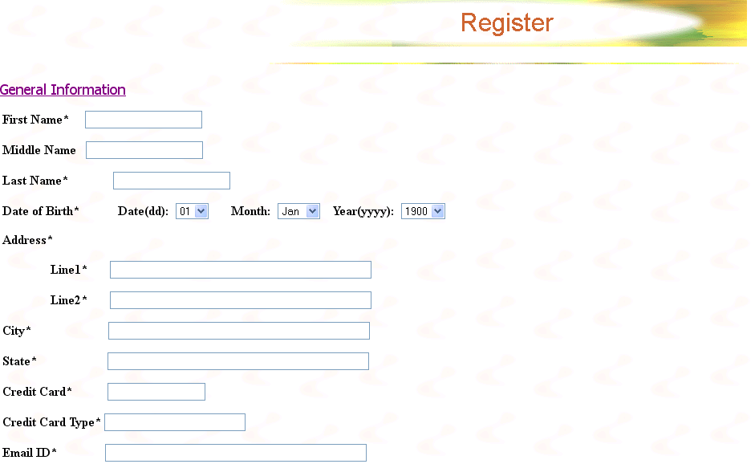

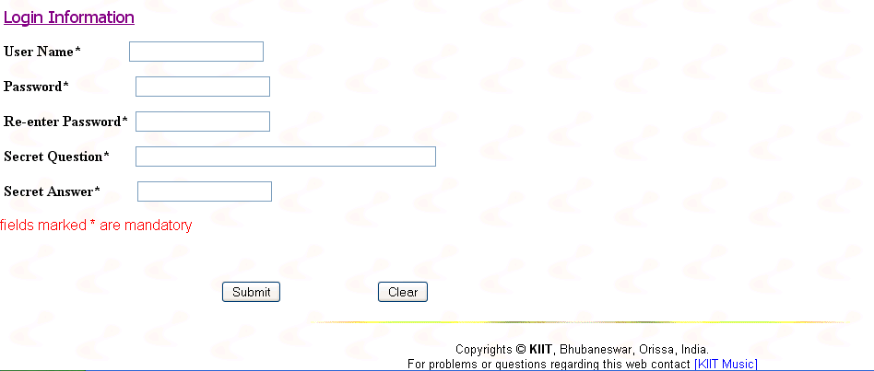7. WAP in java in main() method which will display HELLO JAVA on the screen.

8. WAP in java which will accept **KIIT University** as the command argument and display the same.

9. WAP in java which will accept N number from command line argument and it will display the total number of even, total number of odd, sum of even, sum of odd and the GRAND TOTAL.

10. WAP in java which will accept 10 integers from the command prompt and display the every alternate integer.